|  |  |
| --- | --- |
| **氏　名** | **住　　所** |
|  |  |
|  |  |
|  |  |
|  |  |
|  |  |
|  |  |
|  |  |
|  |  |
|  |  |
|  |  |

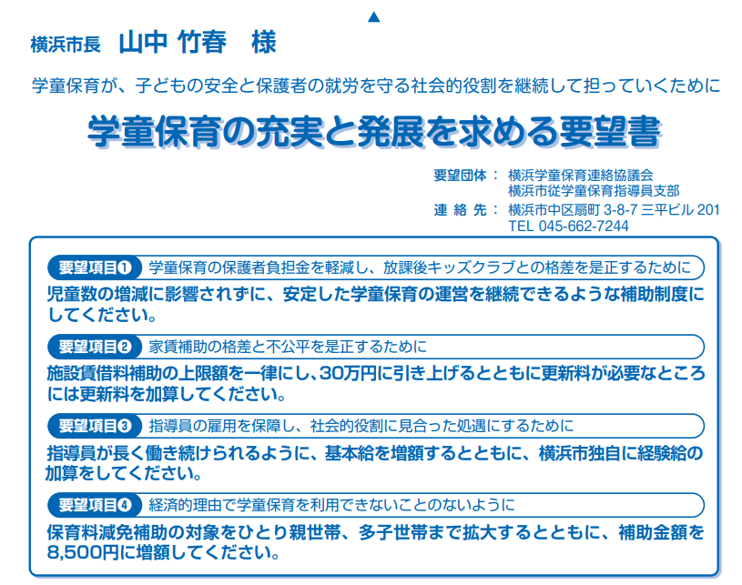

|  |  |
| --- | --- |
| **氏　名** | **住　　所** |
|  |  |
|  |  |
|  |  |
|  |  |
|  |  |
|  |  |
|  |  |
|  |  |
|  |  |
|  |  |

